

**Group Report**

*ISV2017 - WEB DESIGN AND DEVELOPMENT*

**Group Name :** Group 1 – Web du lịch

**Member 1     :** Tran Le Tuong Vy - 23070229

**Member 2     :** Tran Thi Tuyet Mai - 23070034

**Member 3     :** Luu Khanh Huyen - 23070269

**Member 4     :** Nguyen Phuong Anh - 23070285

**Member 5     :** Dao Manh Duc - 23070524

**Member 6     :** Nguyen Quoc Anh Quan

**Instructor**  : Dr. Pham Duc Tho

**Table of Contents**

❖ **General Information** 3

**1.** **Introduction** 4

**2.** **Design** 4

**3.** **Implementation** 8

3.1 Tran Le Tuong Vy – 23070229 8

3.2 Tran Thi Tuyet Mai - 23070034 12

3.3 Luu Khanh Huyen - 23070269 16

3.4 Nguyen Phuong Anh - 23070285 21

3.5 Dao Manh Duc - 23070524 23

**4.** **Conclusion** 31

❖ **Bibliography** 32

**Table of Figures**

**List of Tables**

Table 1 - Project Information 3

Table 2 - Member role 3

# **General Information**

|  |  |
| --- | --- |
| Group name | Group 1 - Travel website |
| Repository URL | *https://github.com/nhoms1/nhoms1.github.io* |
| Web Hosting URL | *https://nhoms1.github.io/* |
| Screen cast URL | https://www.youtube.com/watch?v=ZwXE8w8Tvss |

*Table 1 - Project Information*

|  |  |
| --- | --- |
| Full Name | Role |
| Tran Le Tuong Vy | Report editor, Sitemap, Conclusion, Bibliography |
| Tran Thi Tuyet Mai | Introduction, Conclusion, Bibliography |
| Luu Khanh Huyen | Report editor, Conclusion, Wireframes, Bibliography |
| Nguyen Phuong Anh | Report editor, Conclusion, Bibliography |
| Dao Manh Duc | Making a YouTube video introduce about our group travel website, Conclusion, Bibliography |

*Table 2 – Member Role*

# **Introduction**

In group 1, we presented about tourism websites. Here, the place we choose to introduce is Hue - the ancient capital of Vietnam. The website presents some unique features of Hue as well as introducing outstanding destinations and activities of Hue. In addition, this website also offers a few suggestions about famous hotels as well as room categories for tourists to refer to. In addition, there are also restaurants with famous Hue specialties. Finally, the website has a contact information page for tourists to refer to and make reservations so we can give more detailed advice about this historical site.

# **Design**

* SITEMAP

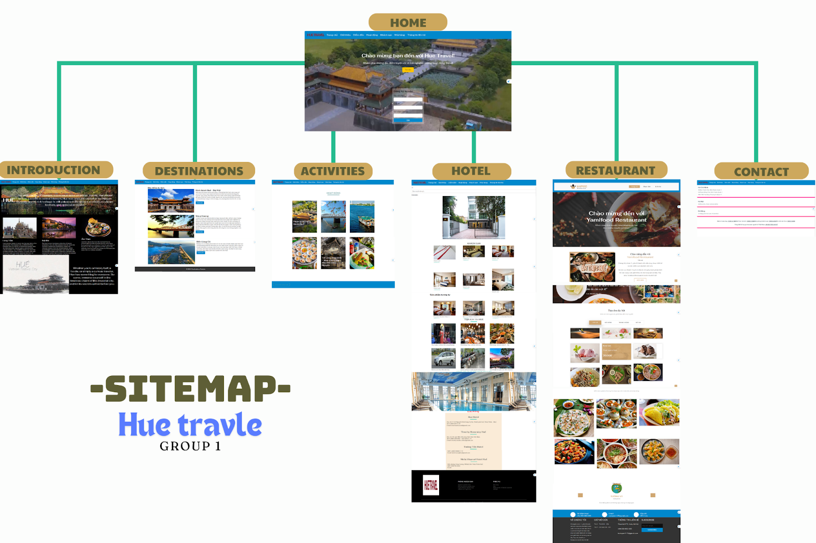

* WIREFRAMES
* Home page:

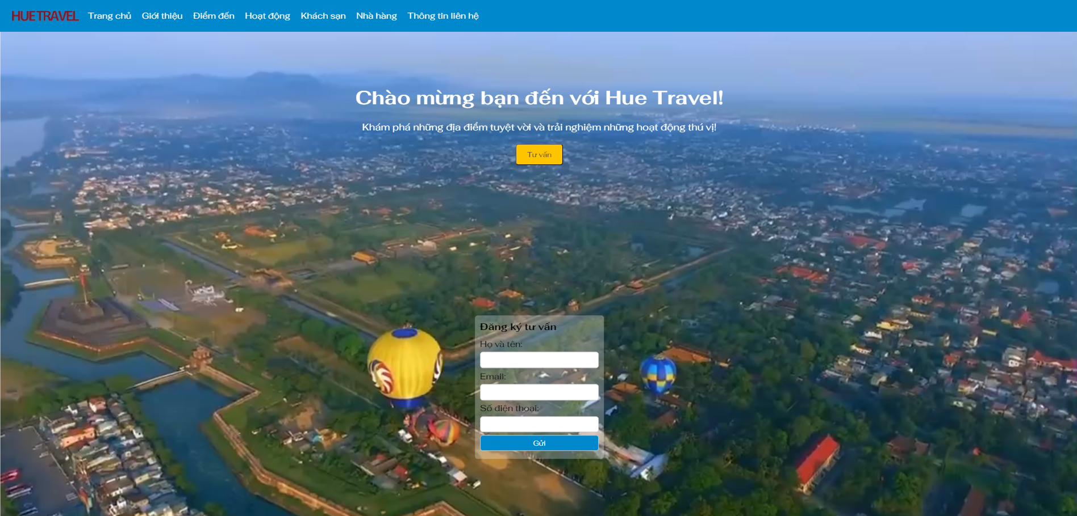

* Introduction:

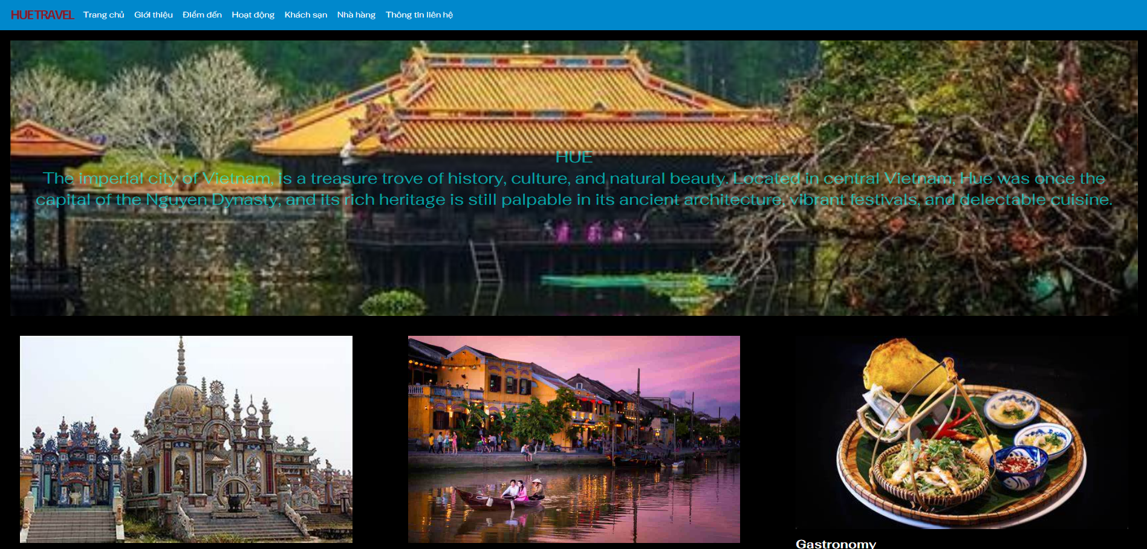

* Destinations:

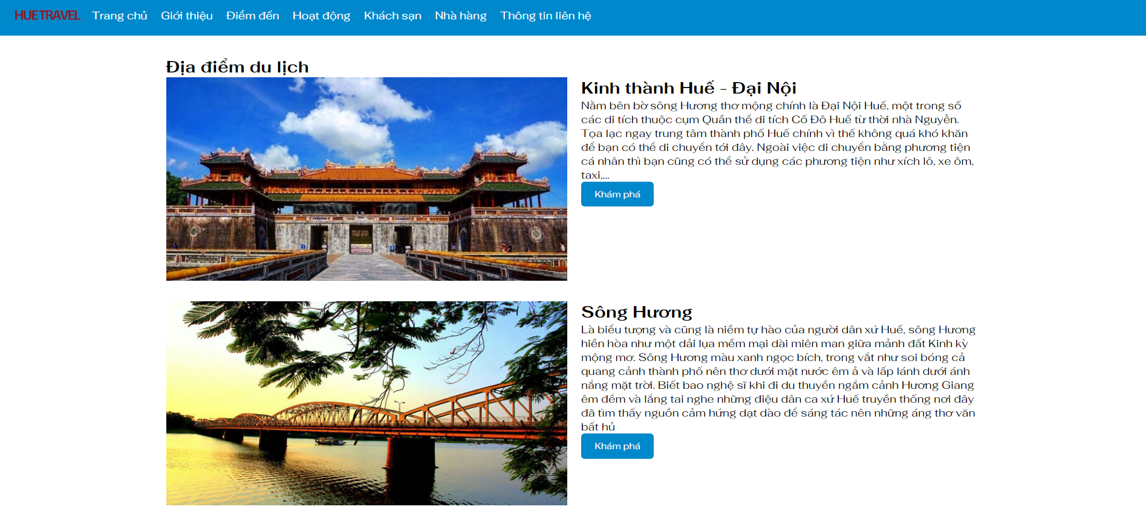

* Activities:

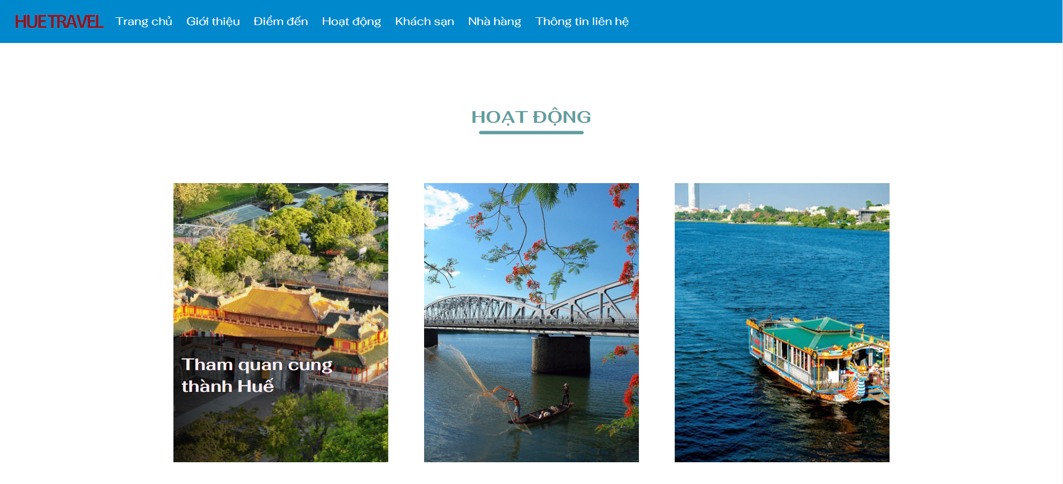

* Hotel:

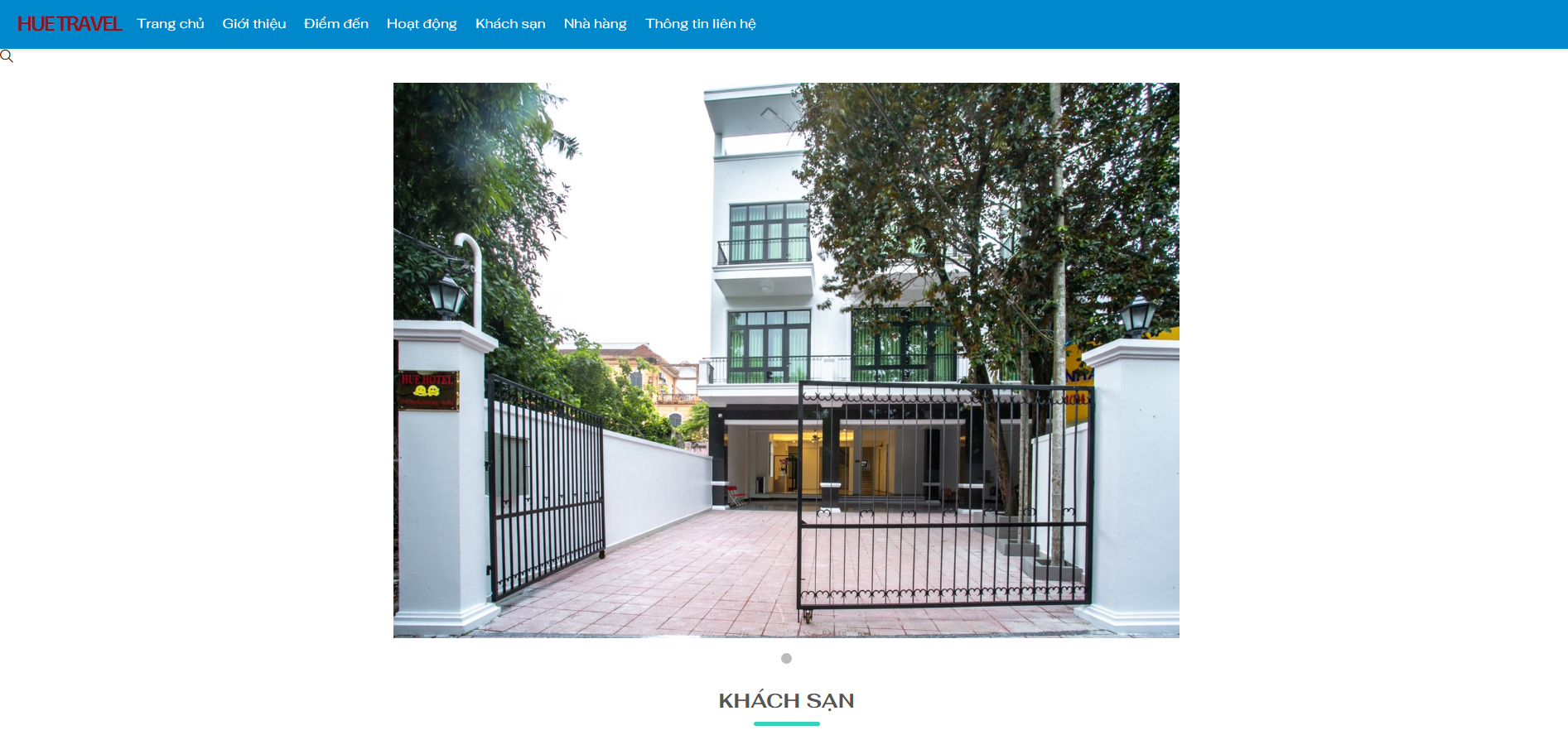

* Restaurant:

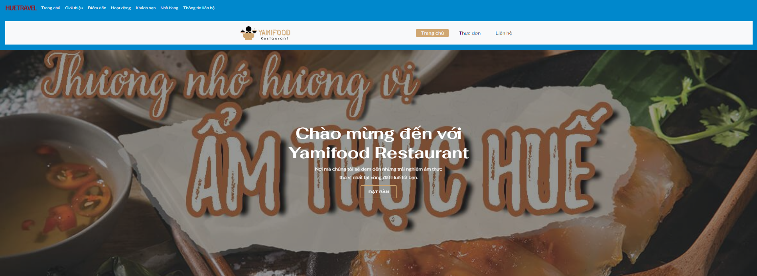

* Contact:

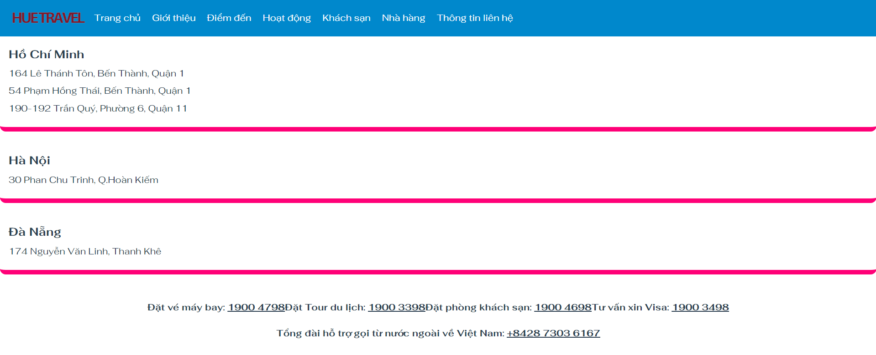

# **Implementation**

## Tran Le Tuong Vy – 23070229

* **Home page**
* ***Using HTML:***

The *<section>* tag is employed to logically divide a webpage.

The *<nav>* tag is used to group navigation menus.

**Example:**

*<nav>*

*<img src="logo1.png" alt="Hue Travel Logo" class="logo">*

*<ul>*

*<li><a href="index.html">Trang chủ</a></li>*

*<li><a href="about.html">Giới thiệu</a></li>*

*<li><a href="destinations.html">Điểm đến</a></li>*

*<li><a href="hoatdong.html">Hoạt động</a></li>*

*<li><a href="khachsan.html">Khách sạn</a></li>*

*<li><a href="restaurant.html">Nhà hàng</a></li>*

*<li><a href="thongtinlienhe.html">Thông tin liên hệ</a></li>*

*</ul>*

*</nav>*

The *<div>* tag is used to group multiple HTML elements together

The *<ul>* and <li> tags are used to create lists

The *<img>* tag is used to insert images

Using <meta charset = “UTF-8”> ensures that the font doesn’t display errors

* HTML tags used in building a banner

*<header>*

*<nav>*

*<img src="logo1.png" alt="Hue Travel Logo" class="logo">*

*<ul>*

*<li><a href="index.html">Trang chủ</a></li>*

*<li><a href="about.html">Giới thiệu</a></li>*

*<li><a href="destinations.html">Điểm đến</a></li>*

*<li><a href="hoatdong.html">Hoạt động</a></li>*

*<li><a href="khachsan.html">Khách sạn</a></li>*

*<li><a href="restaurant.html">Nhà hàng</a></li>*

*<li><a href="thongtinlienhe.html">Thông tin liên hệ</a></li>*

*</ul>*

*</nav>*

*</header>*

* HTML tags for writing introduction content on the homepage

*<section class="hero">*

*<div class="container">*

*<h1>Chào mừng bạn đến với Hue Travel!</h1>*

*<p>Khám phá những địa điểm tuyệt vời và trải nghiệm những hoạt động thú vị!</p>*

*<button onclick="showForm()" class="btn">Tư vấn</button>*

*</div>*

*</section>*

* ***Using CSS:***

Basic attributes: Font-family, font-size, padding, margin, width, height, display (block or inline, flex, …)

position => determines the positioning of content elements inside

background => sets the background color or inserts an image into the background

transition => controls the speed of animation effects

border-radius => formats the border with rounded corners

text-align : left, right, center,… => aligns texts within a block element

align-items: center : Centered

display: flex : Using flexbox for menu and logo

* ***Using Javascript:***

*<script>*

*function showForm() {*

*var form = document.getElementById("consultationForm");*

*form.style.display = "block";*

*}*

*</script>*

The showForm() function changes the CSS property of an HTML element with the id “consultationForm” to display it on the web page.

var form = document.getElementById("consultationForm"): retrieves the HTML element with the id “consultationForm” and assigns it to the variable form

form.style.display = "block"; sets the CSS display property of the from element to “block”. When the display property is set to “block”, the element will be displayed as a block-level element, taking up a line on the page and can have specified width and height

* **Activities**
* **Using HTML:**

*<head>*: This tag contains the headers, CSS files, JavaScript scripts, and other information of the webpage.

*<title>*: This tag is used inside <head> to define the title of the webpage, displayed on the browser's title bar.

*<body>*: This tag contains all the content displayed on the webpage, including text, images, and other HTML elements.

*<header>*: This tag is used to define the header section of the webpage, typically containing the title, logo, and navigation menu.

*<nav>*: This tag represents the navigation section of the webpage, usually containing links to other pages or navigation elements.

*<main>*: This tag contains the main content of the webpage, where the primary content is displayed to users.

*<section>*: This tag is used to group related content together within a region of the webpage.

*<article>*: This tag defines an independent piece of content within the webpage, such as a blog post, news article, or story.

*<aside>*: This tag represents a section of the webpage that can be considered supplementary or not directly related to the main content, such as a sidebar.

*<footer>*: This tag contains end-of-page information, such as contact details or important links.

*<p>*: This tag is used to define a paragraph of text.

*<a>*: This tag creates a hyperlink to another webpage or a location on the same page.

*<img>*: This tag is used to insert images into the webpage.

*<li>*: this tag is represents an item in a list

*<div>*: This tag is a commonly used element to group and divide other HTML elements for styling with CSS.

*<span>*: This tag is used to apply styling, CSS, or JavaScript processing to a small part of text.

*<form>*: This tag creates a form on the web page for users to input data and submit to the server.

*<input>*: This tag creates an input field within a form, allowing users to input data such as text, numbers, or select options.

* **Using CSS:**

*box-sizing:* calculates the size of an element, specifically whether the elements’s size include content, padding and border.

*list-style-type: none:* When this property is applied, these bullets will not be displayed, making the list items appear as a series of contiguous items.

*border-radius:* format rounder border shapes.

*overflow: hidden:* to handle content beyond the containing element (container) when the size of the child element is larger than the size of the containing element.

*object-fit: cover :* adjusts how an image element (or a *<video>, <iframe>, <embed>, <object>* tag) inside a frame element (*<img>* tag or elements with width and height attributes are defined) will cover or adjust the size.

## Tran Thi Tuyet Mai - 23070034

* ***Using HTML:***

The <div> tag is used to group HTML elements together

The <img> tag is used to insert images

The <h2> tag is used to define a level 2 heading for web content

The tag <a> is used to create a link ( hyperlink ) to another website

**Example:**

*<div class="small-container" style="margin-top:10px">*

*<h2 class="title">KHÁCH SẠN</h2>*

*<div class="row" style="margin-top:-60px">*

*<div class="col-4">*

*<a href="product-detail.aspx">*

*<img src="images/phong1.jpg"/>*

*</a>*

*<h4>khach san</h4>*

*<p>500000đ</p>*

*</div>*

*<div class="col-4">*

*<a href="product-detail.aspx">*

*<img src="web_khachsan/images/phong4.jpg"/>*

*</a>*

*<h4>khach san</h4>*

*<p>700000đ</p>*

*</div>*

*<div class="col-4">*

*<a href="product-detail.aspx">*

*<img src="web_khachsan/images/phong5.jpg"/>*

*</a>*

*<h4>khach san</h4>*

*<p>900000đ</p>*

*</div>*

*<div class="col-4">*

*<a href="product-detail.aspx">*

*<img src="web_khachsan/images/phong6.jpg"/>*

*</a>*

*<h4>khach san</h4>*

*<p>1000000đ</p>*

*</div>*

*<div class="col-4">*

*<a href="product-detail.aspx">*

*<img src="web_khachsan/images/phong9.jpg"/>*

*</a>*

*<h4>khach san</h4>*

*<p>1500000đ</p>*

*</div>*

*<div class="col-4">*

*<a href="product-detail.aspx">*

*<img src="web_khachsan/images/phong10.jpg"/>*

*</a>*

*<h4>khach san</h4>*

*<p>2000000đ</p>*

*</div>*

*</div>*

*</div>*

* ***Using CSS:***

The **flex-basis** property is used in the flexbox model to determine the initial size of an item in a flex container

The **padding** property is used to add spacing inside an element

The **margin-bottom** property determines the spacing between the current element and the element below it

The **transition** property is used to create smooth transition effects when the state of an changes

***Example:***

*.col-4 {*

*flex-basis: 25%;*

*padding: 10px;*

*min-width: 200px;*

*margin-bottom: 50px;*

*transition: transform 0.5s;*

*}*

*.col-4:hover {*

*transform: translateY(-10px);*

*}*

*.col-4 img {*

*width: 100%;*

*}*

* **Contact Information**
* ***Using HTML:***

The <div> tag is used to group HTML elements together

***Example:***

*<div class="contact-info">*

*<div class="contact-left">*

*<div class="city">Hồ Chí Minh</div>*

*<div class="address">164 Lê Thánh Tôn, Bến Thành, Quận 1</div>*

*<div class="address">54 Phạm Hồng Thái, Bến Thành, Quận 1</div>*

*<div class="address">190-192 Trần Quý, Phường 6, Quận 11</div>*

*</div>*

*</div>*

* ***Using CSS:***
* **margin-bottom:** Create space below the element.
* **display: flex:** Use the flexbox model to manage elements inside contact-info.
* **justify-content: center** Align elements inside horizontally centered.
* **align-items: center:** Align elements inside vertically centered.
* **text-align: center:** Center-align content of the element horizontally.
* **flex-wrap: wrap:** If content exceeds the width of the element, inner elements will be wrapped and stacked vertically below.

***Example:***

*.contact-info {*

*margin-bottom: 20px;*

*display: flex;*

*justify-content: center;*

*align-items: center;*

*color: #2c3e50;*

*text-align: center;*

*flex-wrap: wrap;*

*background-color: rgba(255, 255, 255, 0.8);*

*padding: 15px;*

*border-radius: 10px;*

*}*

## Luu Khanh Huyen - 23070269

* ***Using HTML:***

The *<head>* tag contains the headers, CSS files, JavaScript scripts, and other information of the webpage.

The *<title>* tag is used inside <head> to define the title of the webpage, displayed on the browser's title bar.

The *<body>* tag contains all the content displayed on the webpage, including text, images, and other HTML elements.

The *<header>* tag is used to define the header section of the webpage, typically containing the title, logo, and navigation menu.

The *<nav>* tag represents the navigation section of the webpage, usually containing links to other pages or navigation elements.

The *<main>* tag contains the main content of the webpage, where the primary content is displayed to users.

The *<section>* tag is used to group related content together within a region of the webpage.

The *<footer>* tag contains end-of-page information, such as contact details or important links.

The *<div>* tag is used to group multiple HTML elements together.

The *<ul>* and *<li>* tags are used to create lists

The *<img>* tag is used to insert images

The *<a>* tag is used to insert additional links (hyperlinks) to another page.

**Example 1:**

*<nav class="navbar navbar-expand-lg navbar-light bg-light">*

*<div class="container">*

*<a class="navbar-brand" href="restaurant.html">*

*<img src="images/logo1.png" alt="" />*

*</a>*

*<button class="navbar-toggler" type="button"data-toggle="collapse" data-target="#navbars-rs-food"*

*aria-controls="navbars-rs-food" aria-expanded="false" aria-label="Toggle navigation">*

*<span class="navbar-toggler-icon"></span>*

*</button>*

*<div class="collapse navbar-collapse" id="navbars-rs-food">*

*<ul class="navbar-nav ml-auto">*

*<li class="nav-item active"><a class="nav-link" href="restaurant.html">Trang chủ</a></li>*

*<li class="nav-item"><a class="nav-link" href="menu.html">Thực đơn</a></li>*

*<li class="nav-item"><a class="nav-link" href="contact.html">Liên hệ</a></li>*

*</ul>*

*</div>*

*</div>*

*</nav>*

**Example 2:**

*<head>*

*<meta charset="utf-8">*

*<meta http-equiv="X-UA-Compatible" content="IE=edge">*

*<!-- Mobile Metas -->*

*<meta name="viewport" content="width=device-width, initial-scale=1">*

*<!-- Site Metas -->*

*<title>Yamifood Restaurant - Responsive HTML5 Template</title>*

*<meta name="keywords" content="">*

*<meta name="description" content="">*

*<meta name="author" content="">*

*<!-- Site Icons -->*

*<link rel="shortcut icon" href="images/favicon.ico" type="image/x-icon">*

*<link rel="apple-touch-icon" href="images/apple-touch-icon.png">*

*<!-- Bootstrap CSS -->*

*<link rel="stylesheet" href="css/bootstrap.min.css">*

*<!-- Site CSS -->*

*<link rel="stylesheet" href="css/style1.css">*

*<!-- Responsive CSS -->*

*<link rel="stylesheet" href="css/responsive1.css">*

*<!-- Custom CSS -->*

*<link rel="stylesheet" href="css/custom.css">*

*<!--[if lt IE 9]>*

*<script src="https://oss.maxcdn.com/libs/html5shiv/3.7.0/html5shiv.js"></script>*

*<script src="https://oss.maxcdn.com/libs/respond.js/1.4.2/respond.min.js"></script>*

*<![endif]-->*

*</head>*

**Example 3:**

*<body>*

*<!-- Start header -->*

*<header class="top-navbar">*

*<nav class="navbar navbar-expand-lg navbar-light bg-light">*

*<div class="container">*

*<a class="navbar-brand" href="restaurant.html">*

*<img src="images/logo1.png" alt="" />*

*</a>*

*<button class="navbar-toggler" type="button" data-toggle="collapse" data-target="#navbars-rs-food"*

*aria-controls="navbars-rs-food" aria-expanded="false" aria-label="Toggle navigation">*

*<span class="navbar-toggler-icon"></span>*

*</button>*

*<div class="collapse navbar-collapse" id="navbars-rs-food">*

*<ul class="navbar-nav ml-auto">*

*<li class="nav-item active"><a class="nav-link" href="restaurant.html">Trang chủ</a></li>*

*<li class="nav-item"><a class="nav-link" href="menu.html">Thực đơn</a></li>*

*<li class="nav-item"><a class="nav-link" href="contact.html">Liên hệ</a></li>*

*</ul>*

*</div>*

*</div>*

*</nav>*

*</header>*

Using <meta charset = “UTF-8”> ensures that the font doesn’t display errors

* ***Using CSS:***

Basic attributes: *Font-family, font-size, padding, margin, width, height, display (block or inline, flex, …)*

*position*: Determine the position of content elements inside

*background color*

*transition:* effect speed control

*box-shadow:* adjust the brightness level

**Example:**

*.top-navbar{*

*position: relative;*

*z-index: 10;*

*}*

*.top-navbar .navbar{*

*padding: 15px 0px;*

*/* position: fixed; */*

*width: 100%;*

*transition: height .3s ease-out, background .3s ease-out, box-shadow .3s ease-out;*

*-webkit-transform: translate3d(0, 0, 0);*

*transform: translate3d(0, 0, 0);*

*z-index: 100;*

*}*

*.top-navbar .navbar-light .navbar-nav .nav-link{*

*color: #010101;*

*font-size: 18px;*

*padding: 0px 20px;*

*border-radius: 4px;*

*}*

*.top-navbar .navbar-light .navbar-nav .nav-item .nav-link:hover{*

*background: #d0a772;*

*color: #ffffff;*

*}*

*.top-navbar .navbar-light .navbar-nav .nav-item.active .nav-link{*

*background: #d0a772;*

*color: #ffffff;*

*border-radius: 4px;*

*}*

*.navbar-expand-lg .navbar-nav .dropdown-menu{*

*border: none;*

*box-shadow: 2px 5px 6px rgba(0,0,0,0.5);*

*}*

*.navbar-expand-lg .navbar-nav .dropdown-menu a.dropdown-item:hover{*

*background: #d0a772;*

*color: #ffffff;*

*}*

*.navbar-light .navbar-toggler:hover{*

*background: #cfa671;*

The *<cursor: pointer contribute>*: displays the mouse cursor as a pointer when hovering over the element

The *<text-transform: uppercase>*: property transforms all text in an element to uppercase

*.filter-button-group button {*

*color: #333;*

*letter-spacing: 1px;*

*text-transform: uppercase;*

*font-weight: 600;*

*font-size: 14px;*

*cursor: pointer;*

*background: #fff;*

*padding: 12px 40px;*

*border: none;*

*border-radius: 4px;*

*}*

## Nguyen Phuong Anh - 23070285

* ***Using HTML:***

The <section> tag is employed to logically divide a webpage

The <div> tag is used to group multiple HTML elements together

The <img> tag is used to insert images

The < button > tag creates a button on a webpage

*<section class="destinations">*

*<div class="container">*

*<h1>Địa điểm du lịch</h1>*

*<div class="destinations-content row">*

*<div class="destinations-content-item row">*

*<div class="destinations-content-item-img">*

*<img src="kinhthanhhue.jpg" alt="Kinh thành Huế">*

*</div>*

*<div class="destinations-content-item-text">*

*<h2>Kinh thành Huế - Đại Nội</h2>*

*<p> Nằm bên bờ sông Hương thơ mộng chính là Đại Nội Huế, một trong số các di tích thuộc cụm Quần thể*

*di tích Cố Đô Huế từ thời nhà Nguyễn. Tọa lạc ngay trung tâm thành phố Huế chính vì thế không quá*

*khó khăn để bạn có thể di chuyển tới đây. Ngoài việc di chuyển bằng phương tiện cá nhân thì bạn*

*cũng có thể sử dụng các phương tiện như xích lô, xe ôm, taxi,...</p>*

*<button>Khám phá</button>*

*</div>*

*</div>*

* ***Using CSS:***

Basic attributes: Font-family, font-size, padding, margin, width, height, display (block or inline, flex, …)

object-fit: specifies how an image or video resizes within an HTML element

background: background color

transition: transition effect

border-radius: rounded corners

text-align: text alignment

*.destinations-content-item-img img{*

*width: 100%;*

*height: 100%;*

*object-fit: cover;*

*}*

*.container {*

*max-width: 1200px;*

*margin: 0 auto;*

*}*

*.destinations-content-item {*

*display: flex;*

*margin-bottom: 30px;*

*}*

*.destinations-content-item-img {*

*width: 50%;*

*}*

*.destinations-content-item-text {*

*width: 50%;*

*margin-left: 20px;*

*}*

*\* {*

*box-sizing: border-box;*

*margin: 0;*

*padding: 0;*

*}*

*button {*

*background-color: #0088CC;*

*color: #fff;*

*border: none;*

*padding: 10px 20px;*

*border-radius: 5px;*

*cursor: pointer;*

*transition: background-color 0.3s ease;*

*}*

## Dao Manh Duc - 23070524

* ***Using html:***

The *<meta>* tag is used to define metadata about the web page, such as the character set and viewport.

 The <*charset>* attribute is used to specify the character encoding of the web page.

The <*viewport>* attribute is used to control the layout of the web page on different devices.

The <*lang>* attribute is used to specify the language of the web page.

The *<img>* tag is used to display the logo.

The *<ul>* tag is used to create an unordered list of links.

The *<li>* tag is used to create list items for each link.

The <*a>* tag is used to create hyperlinks for each list item.

The <*href>* attribute is used to specify the URL of the page that the link goes to.

The <*alt>* attribute is used to provide alternative text for the logo.

The <*class>* attribute is used to apply CSS styles to this container.

The *<body>*tag has a black background color, white text color, and a specific font family.

The <*container>*class is used to center the content of the web page.

The *<header>*class defines the header section of the web page with a background image, centered text, and padding.

The *<row.*class is used to create a row of elements with equal spacing between them.

The <*column>* class is used to define the width of each column.

The <*h2>* and <*p>*tags define the font size for headings and paragraphs, respectively.

The <*footer-text>* class is used to define the width and padding of the text in the footer.

 The <*div>* tag is used to container with a class.

**Example:**

*<!DOCTYPE html>*

*<html lang="en">*

*<head>*

*<meta charset="UTF-8">*

*<meta name="viewport" content="width=device-width, initial-scale=1.0">*

*<header>*

*<nav>*

*<img src="logo1.png" alt="Hue Travel Logo" class="logo">*

*<ul>*

*<li><a href="index.html">Trang chủ</a></li>*

*<li><a href="about.html">Giới thiệu</a></li>*

*<li><a href="destinations.html">Điểm đến</a></li>*

*<li><a href="hoatdong.html">Hoạt động</a></li>*

*<li><a href="khachsan.html">Khách sạn</a></li>*

*<li><a href="restaurant.html">Nhà hàng</a></li>*

*<li><a href="thongtinlienhe.html">Thông tin liên hệ</a></li>*

*<link rel="stylesheet" href="about.css">*

*</ul>*

*</nav>*

*</header>*

*<title>Programming Website</title>*

*<style>*

*body {*

*background-color: #000;*

*color: #fff;*

*font-family: "Fahkwang", sans-serif;*

*margin: 0;*

*padding: 0;*

*}*

*.container {*

*display: flex;*

*flex-direction: column;*

*align-items: center;*

*padding: 20px;*

*}*

*.header {*

*background-image: url('https://i.pinimg.com/564x/59/64/b7/5964b743633c09ec01ecaf84d99359e5.jpg');*

*background-size: cover;*

*background-position: center;*

*height: 50vh;*

*display: flex;*

*justify-content: center;*

*align-items: center;*

*text-align: center;*

*color: #00fffb9c;*

*font-size: 2em;*

*padding: 20px;*

*margin-bottom: 20px;*

*}*

*.row {*

*display: flex;*

*justify-content: space-between;*

*padding: 20px;*

*margin-bottom: 20px;*

*}*

*.column {*

*width: 30%;*

*}*

*h2 {*

*font-size: 1.5em;*

*margin-bottom: 10px;*

*}*

*p {*

*font-size: 1em;*

*}*

*.image {*

*width: 100%;*

*margin-bottom: 10px;*

*}*

*.footer {*

*background-size: cover;*

*background-position: center;*

*height: 50vh;*

*display: flex;*

*justify-content: center;*

*align-items: center;*

*text-align: center;*

*color: #fff;*

*font-size: 2em;*

*padding: 20px;*

*margin-top: 20px; /* Thêm margin-top để tạo khoảng cách trên */*

*}*

*.footer-text {*

*width: 70%;*

*text-align: center;*

*padding: 20px;*

*margin-bottom: 20px;*

*}*

*</style>*

*</head>*

*<body>*

*<div class="container">*

*<div class="header">*

*<h1></h1>*

*<p>HUE <br> The imperial city of Vietnam, is a treasure trove of history, culture, and natural beauty. Located in central Vietnam, Hue was once the capital of the Nguyen Dynasty, and its rich heritage is still palpable in its ancient architecture, vibrant festivals, and delectable cuisine.</p>*

*</div>*

*<div class="row">*

*<div class="column">*

*<img src="https://th.bing.com/th/id/OIP.doFl1js22p-z2akgnCrpiAHaEo?rs=1&pid=ImgDetMain" alt="Lăng Tẩm" class="image">*

*<h2>Mausoleum</h2>*

*<p>Hue's storied history is woven into the very fabric of its architecture. The Imperial City, a UNESCO World Heritage Site, is a marvel of Vietnamese design, with its imposing walls, majestic gates, and intricately carved temples. The Forbidden Purple City, once the exclusive domain of the emperor, is a must-visit, with its opulent halls and ornate gardens. And then, of course, there are the royal tombs, each one a testament to the grandeur and beauty of a bygone era.</p>*

*</div>*

*<div class="column">*

*<img src="https://vietlongtravel.com/wp-content/uploads/2015/03/Hoi-an-tour.jpg" alt="Nội Đô" class="image">*

*<h2>Inner-city</h2>*

*<p>But Hue is more than just a collection of historic landmarks. It's a city that pulsates with life, where the rhythms of traditional Vietnamese culture still resonate deeply. From the vibrant markets, where locals haggle over fresh produce and handicrafts, to the tranquil riverside, where fishermen cast their nets beneath the golden light of dawn, Hue is a city that will captivate your senses and steal your heart.</p>*

*</div>*

*<div class="column">*

*<img src="https://th.bing.com/th/id/OIP.amPw0rpbCmTQ9yPsVPd6EQHaEU?rs=1&pid=ImgDetMain" alt="Ẩm Thực" class="image">*

*<h2>Gastronomy</h2>*

*<p>And then, there's the food. Oh, the food! Hue is renowned for its bold, aromatic flavors, which have been perfected over centuries. From the spicy kick of bun bo hue, the city's signature noodle soup, to the delicate crunch of banh ep, a crispy rice flour pancake, every bite is a culinary revelation.</p>*

*</div>*

*</div>*

*<div class="footer">*

*<img src="https://i.pinimg.com/474x/ef/c1/1b/efc11bf335817c1c50bc8f5e069ea360.jpg" style="width: 100%; height: auto;">*

*<div class="footer-text">*

*<p>Whether you're a history buff, a foodie, or simply a curious traveler, Hue has something for everyone. So come, immerse yourself in the timeless charm of this imperial city, and let its secrets unfold before you.</p>*

*</div>*

*</div>*

*</div>*

*</body>*

*</html>*

* ***Using CSS:***

**color**; sets the text color to ...

**text-decoration**: none; removes any underline or other decoration from the text.

**transition**; adds a smooth transition effect to the color change when the user hovers over the link.

**margin-right**; sets the right margin of an element to ... pixels.

**list-style-type: none**; removes the bullet points from a list.

**margin**; sets the margin of the list to ... pixels.

**padding**; sets the padding of the list to ... pixels.

**display**: flex; sets the display of the list to flex, allowing for flexible and responsive layout.

**max-width**: 130px; sets the maximum width of an image to 130 pixels.

**align-items**: center; aligns the items in the container to the center vertically.

**display: flex**; sets the display of the container to flex, allowing for flexible and responsive layout.

**align-items:** center; aligns the items in the container to the center vertically.

**background-color: #0088CC**; sets the background color of the container to #0088CC.

**box-sizing: border-box**; sets the box-sizing of the container to border-box.

**font-family**: "Fahkwang", sans-serif; sets the font-family of the container to Fahkwang, sans-serif.

*@import url('https://fonts.googleapis.com/css2?family=Fahkwang:ital,wght@0,200;0,300;0,400;0,500;0,600;0,700;1,200;1,300;1,400;1,500;1,600;1,700&family=Inconsolata:wght@200..900&display=swap');*

*\* {*

*margin: 0;*

*padding: 0;*

*box-sizing: border-box;*

*font-family: "Fahkwang", sans-serif;*

*}*

*/* Header */*

*header {*

*display: flex;*

*align-items: center; /* Căn giữa theo chiều dọc */*

*padding: 20px;*

*background-color: #0088CC;*

*}*

*nav {*

*display: flex; /* Sử dụng flexbox cho menu và logo */*

*align-items: center; /* Căn giữa theo chiều dọc */*

*}*

*.logo {*

*max-width: 130px;*

*margin-right: 15px;*

*}*

*nav ul {*

*list-style-type: none;*

*margin: 0;*

*padding: 0;*

*display: flex;*

*}*

*nav ul li {*

*margin-right: 20px;*

*}*

*nav ul li:last-child {*

*margin-right: 0;*

*}*

*nav ul li a {*

*color: #ffffff;*

*text-decoration: none;*

*transition: color 0.3s ease;*

*}*

*nav ul li a:hover {*

*color: #FFC400;*

*}*

# **Conclusion**

* **Overall assessment:**
* The interface and layout of the website still lack modernity and attractiveness compared to other travel websites
* The introductory sections for each category are still rudimentary, lacking sufficient persuasive power
* The website basically have fundamental effect which are easy to use and setup
* The interactive elements on the website are designed clearly, allowing users to interact with ease.
* The website loads fairly quickly and reliably; however, some pages still load slowly.
* **Further improvements:**
* The quality of videos and images on the web should be improved, replaced with higher quality, sharper videos and images
* The color scheme should be consistent across pages, using colors that are vibrant and stand out
* We need to apply more commands to make the website more dynamic
* The website needs to be more consistent in terms of effects, using interconnected effects across each website to create a more harmonious whole.
* Choose easily readable fonts and optimize their sizes for the best readability.

# **Bibliography**

* **Homepage:**
* With the menu on the header of the page, I consult the interface of dulichvietnam’s website. Our logo is put on the top by the left of the page and the menu right beside the logo.

***URL :*** <https://tour.dulichvietnam.com.vn/>

* About the form to register for consultation and take a video as background, I consult the instruction video about how to code a travel website on Youtube but have changed to suit the requirements of the big assignment.

***URL :*** <https://www.youtube.com/watch?v=UH9cgPVcjFA&t=829s>

* **Introduction:**
* About the idea, I didn't get the idea from any source, I just wanted to keep the background black to enhance the prominence of the text. In addition, I also tried to use and fix the color scheme using colorhunt.

***URL:*** [Color Palette: #E4C59E #AF8260 #803D3B #322C2B - Color Hunt](https://colorhunt.co/palette/e4c59eaf8260803d3b322c2b)

* **Destinations:**
* About how to divide the layout and images of tourist destinations, I refer to and follow the instructions for coding tourism websites on Youtube, I change them to suit the requirements of the article.

***URL:*** <https://www.youtube.com/watch?v=Xt9TBNrpzwQ>

* **Activities:**
* See instructions to create vivid, eye-catching motion effects that attract users when entering the activities introduction page. If you don't click it, the entire image will be displayed. If you click it, a short description will appear.

***URL :*** <https://www.youtube.com/watch?v=XS3xByP7FnY>

* **Hotel:**
* I consulted a code video tutorial on hotel booking as well as an introduction to the hotel through a channel on Youtube.

***URL:*** <https://youtu.be/efF_hjWuXac?si=x_1PHUnGqWWZwTRC>

* **Restaurant:**
* As for the code, I learned on social media, asked people around me who knew about coding for reference, found out basic commands to create a restaurant website and follow what I wanted. I also took a look at some colors, effects of some big restaurant’s official pages like Gogi, Manhwa,...

***URL:*** <https://www.youtube.com/watch?v=KVHji5QcWHE>

***URL:*** https://youtu.be/-ZsCfNaSwNQ?si=m1SZqMVMpaJhusLU